Cron jobs :
* * * * * command_to_run
│ │ │ │ │
│ │ │ │ └── Day of week (0 - 6) → 0 = Sunday
│ │ │ └──── Month (1 - 12)
│ │ └────── Day of month (1 - 31)
│ └──────── Hour (0 - 23)
└────────── Minute (0 - 59)

Example | Meaning
* * * * * | Every minute
*/5 * * * * | Every 5 minutes
0 * * * * | Every hour (at minute 0)
0 6 * * * | Every day at 6:00 AM
0 0 * * 0 | Every Sunday at midnight
0 9-17 * * * | Every hour from 9 AM to 5 PM
0 0 1 * * | On the 1st day of every month
30 22 * * 1-5 | At 10:30 PM Monday–Friday
*/10 * * * * /path/script.sh | Run every 10 minutes

Shortcut | Meaning | Equivalent
@reboot | Run once at startup | (none)
@yearly | Once a year | 0 0 1 1 *
@monthly | Once a month | 0 0 1 * *
@weekly | Once a week | 0 0 * * 0
@daily | Once a day | 0 0 * * *
@hourly | Once an hour | 0 * * * *
Task
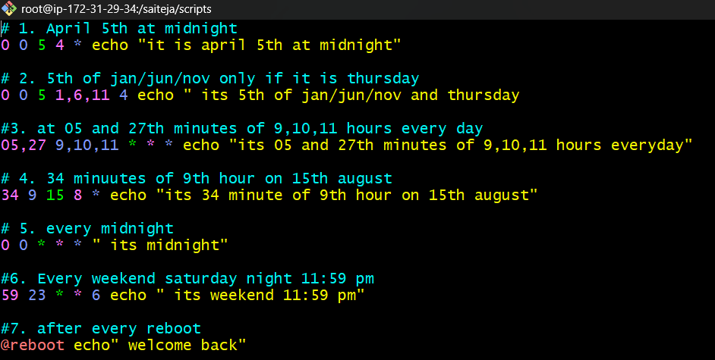

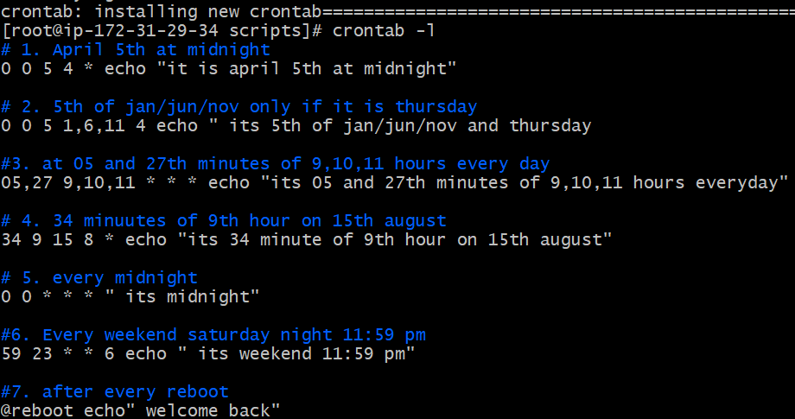
Proofs that above codes are correct
1.
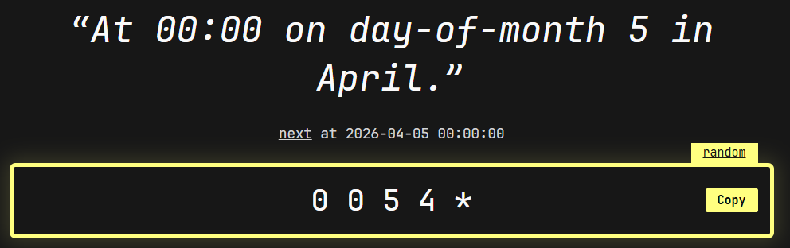
2. 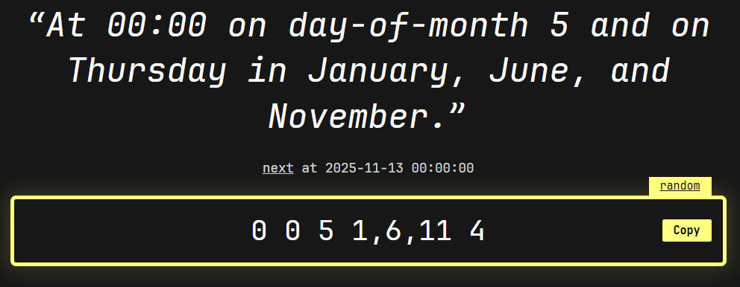
3.
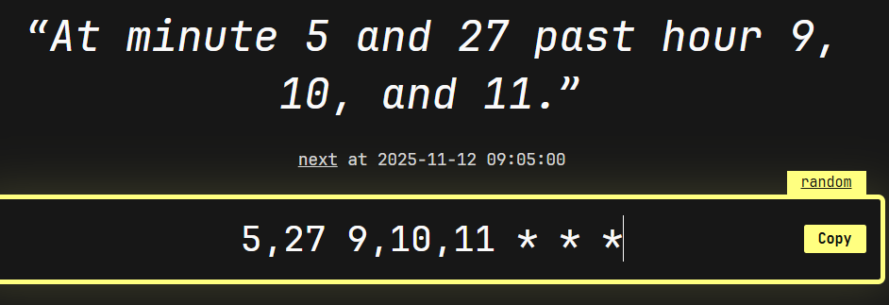
4
. 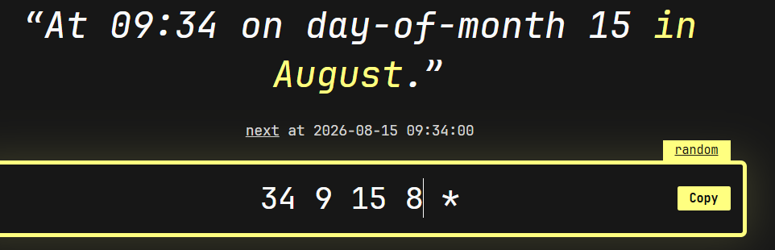

5. 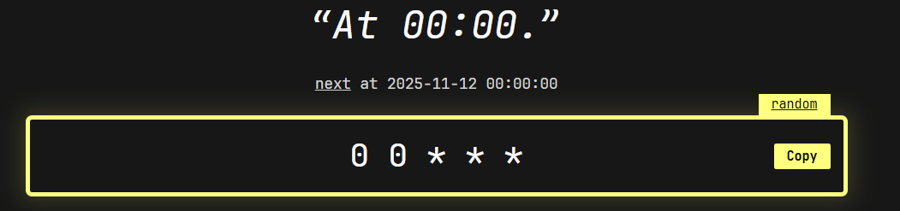
6. 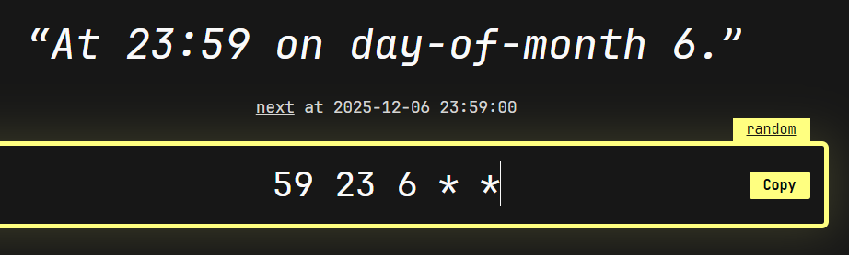
7. 